# MINI PROJECT (2020-21)

**Build a Web Application for Zoom Clone**

**MID-TERM REPORT**



**Institute of Engineering & Technology**

**Submitted by-**

**Vishes Keshari (181500813)**

**Pulkit Ranjan (181500519)**

**Gaurav Kumar (181500233)**

**Aditya Kumar Das (181500041)**

***Supervised By:***

**Harvinder Kaur Ma’am**

Technical Trainer

# Department of Computer Engineering & Applications

**Contents**

|  |  |
| --- | --- |
| **Abstract** | **3** |
| **1. Introduction** | **3** |
| * 1. General Introduction to the topic   2. About | **3**  **4 - 5** |
| 1.3 Area of Computer Science | **6** |
| 1.4 Hardware and Software Requirements | **7** |
| **2. Problem definition** | **7** |
| **3. Objectives** | **8** |
| 4**. Implementation Details** | **8** |
| **5. Progress till Date & The Remaining work** | **9** |
| **6. Some Screenshots** | **10-17** |
| **7. References** | **18** |

**Abstract**

In this we will build a web-based Zoom Clone application using HTML, CSS, JavaScript, Node.js, Express.js, Socket.io, npm, nodemon. It is Social Networking digital communication web application that provides video chat between computers, tablets and mobile devices through web browser. HTML describes the structure of a Web page. CSS describes how HTML elements are to be displayed on screen, paper, or in other media. JavaScript is used mainly for enhancing the interaction of a user with the webpage. Node.js is primarily used for non-blocking, event-driven servers, due to its single-threaded nature. It's used for traditional web sites and back-end API services, but was designed with real-time, push-based architectures in mind. This project is to create a application with a server and client that enables video conferencing and texting in Realtime.

# Introduction

* 1. **General Introduction to the topic**

Our project is an example of a client server application. It is a real-time and multi-platform application and can be used by many users. It provides video telephony and online chat service through a peer to peer service platform and it uses tele-conferencing and tele-commuting. It is made up of 2 applications the client application, which runs on the users’ Pc and server application, which runs on any pc on the network. To start Video chatting client should get connected to the server.

# About

# 1. HTML

# • HTML stands for Hyper Text Markup Language

# • HTML is the standard markup language for creating Web pages

# • HTML describes the structure of a Web page

# • HTML consists of a series of elements

# • HTML elements tell the browser how to display the content

# • HTML elements label pieces of content such as "this is a heading", "this is a paragraph", "this is a link", etc.

# 2. CSS

# • CSS stands for Cascading Style Sheets.

# • CSS describes how HTML elements are to be displayed on screen, paper, or in other media.

# • CSS saves a lot of work. It can control the layout of multiple web pages all at once.

# • External stylesheets are stored in CSS files.

# 3. JavaScript

# JavaScript is a very powerful client-side scripting language. JavaScript is used mainly for enhancing the interaction of a user with the webpage. In other words, you can make your webpage livelier and more interactive, with the help of JavaScript. JavaScript is also being used widely in game development and Mobile application development.

**4. Node.js**

* This is in contrast to today's more common concurrency model, in which OS threads are employed. Thread-based networking is relatively inefficient and very difficult to use. Furthermore, users of Node.js are free from worries of dead-locking the process, since there are no locks. Almost no function in Node.js directly performs I/O, so the process never blocks. Because nothing blocks, scalable systems are very reasonable to develop in Node.js.

# 5. Socket.IO

# Socket.IO enables real-time, bidirectional and event-based communication. It works on every platform, browser or device, focusing equally on reliability and speed.

# Real-time analytics Push data to clients that gets represented as real-time counters, charts or logs.

# Binary streaming: - Starting in 1.0, it's possible to send any blob back and forth: image, audio, video.

# Instant messaging and chat Socket.IO's.

# Document collaboration Allow users to concurrently edit a document and see each other's changes

**6. Express.js**

* Express is a minimal and flexible Node.js web application framework that provides a robust set of features to develop web and mobile applications. It facilitates the rapid development of Node based Web applications. Following are some of the core features of Express framework −
* Allows to set up middleware to respond to HTTP Requests.
* Defines a routing table which is used to perform different actions based on HTTP Method and URL.
* Allows to dynamically render HTML Pages based on passing arguments to templates.

**7. npm**

* npm, Inc. is a company founded in 2014, and was acquired by GitHub in 2020. npm is a critical part of the JavaScript community and helps support one of the largest developer ecosystems in the world.
* npm is lots of things.
* npm is the package manager for Node.js. It was created in 2009 as an open source project to help JavaScript developers easily share packaged modules of code.
* The npm Registry is a public collection of packages of open-source code for Node.js, front-end web apps, mobile apps, robots, routers, and countless other needs of the JavaScript community.
* npm is the command line client that allows developers to install and publish those packages.

**8. Nodemon**

* Nodemon is a tool that helps develop node.js based applications by automatically restarting the node application when file changes in the directory are detected.

# Area of Computer Science

It is Social Networking digital communication web application that provides video chat between computers, tablets and mobile devices through web browser.

1. **Hardware Requirements: -**

* Processor: Minimum 3rd Generation Intel processor or AMD
* Operating System: Windows
* RAM: 128 MB or higher.
* Hardware Devices: PC or Laptop
* Hard disk: 20GB

1. **Software Requirements:**

* Technology Implemented: Web Development and Web-Sockets
* Language Used: HTML, CSS, JavaScript, Node.js
* Web Browser: Google Chrome (Version: 84.0.4147.135 or above)
* Code editor: Windows Visual Studio (Version: 16.0 or above)

**Problem Definition :**

This project is to create a application with a server and client that enables video conferencing and texting in Realtime.

# Objective

* This project is a real-time web application with very simple UI.
* Users can video chat or send and receive text in Realtime.
* To generate an IP Address for multiple users to connect to the same chat room.

# Implementation Details

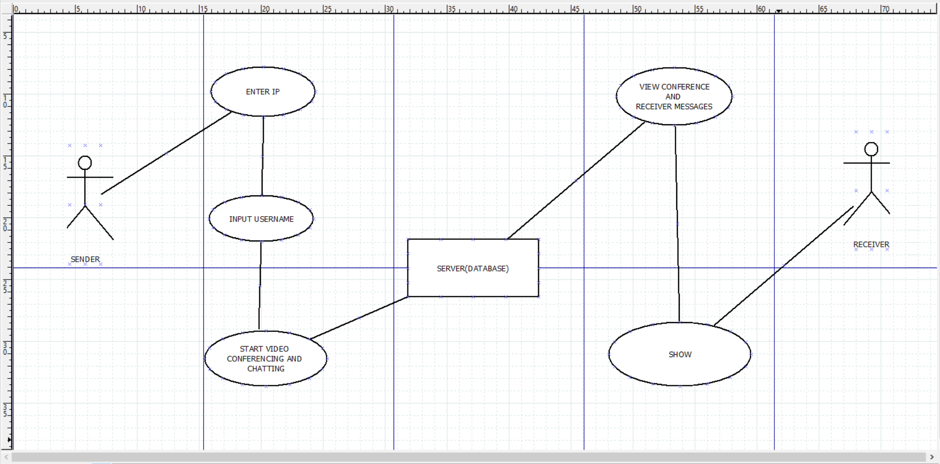

- First, we will work on making design for our website using pencil wireframe.

- Next, we will Initialize our NodeJS Project.

- Then we will Initialize our first view Using HTML.

- After initializing first view we will create a Room ID.

- Then we will add the ability to view our own video.

- Soon after above we will add ability to allow others to stream their video.

- Then we will add Styling Using CSS.

- After adding Styling, we will add the ability to create messages.

- Followed by adding mute button.

- Then at last we will add Stop Video Button too.

# Progress

**.** Initializing Node.JS Project.

**.** Initializing first view using HTML.

**.** Creating Room ID.

**.** Placement of buttons and adding functionality to them.

**.** Adding colour, effects and designing features to different section of web app.

**.** Adding the ability to view our own video.

**Remaining work**

**.** We will add the ability to allow others to stream their video

**.** We will create a medium for messages to pass from sender to server and then from server to receiver.

**.** And at last we will add the feature of scrolling the messages up and down.

**SCREENSHOTS**

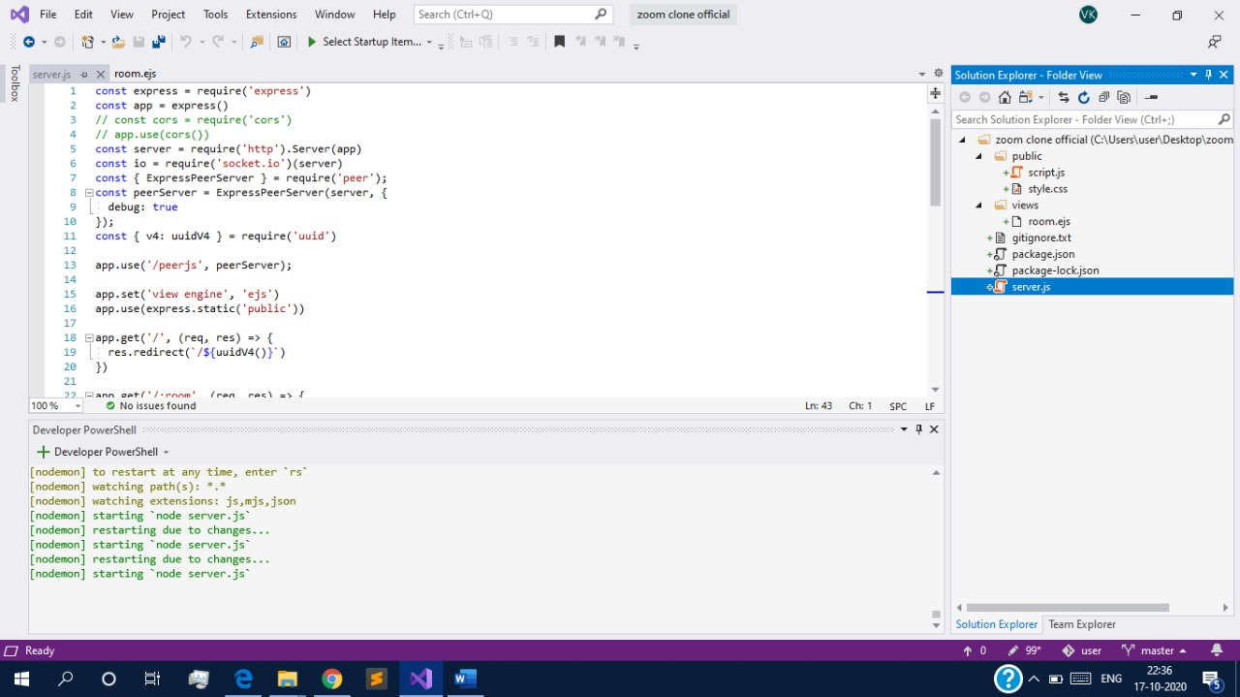

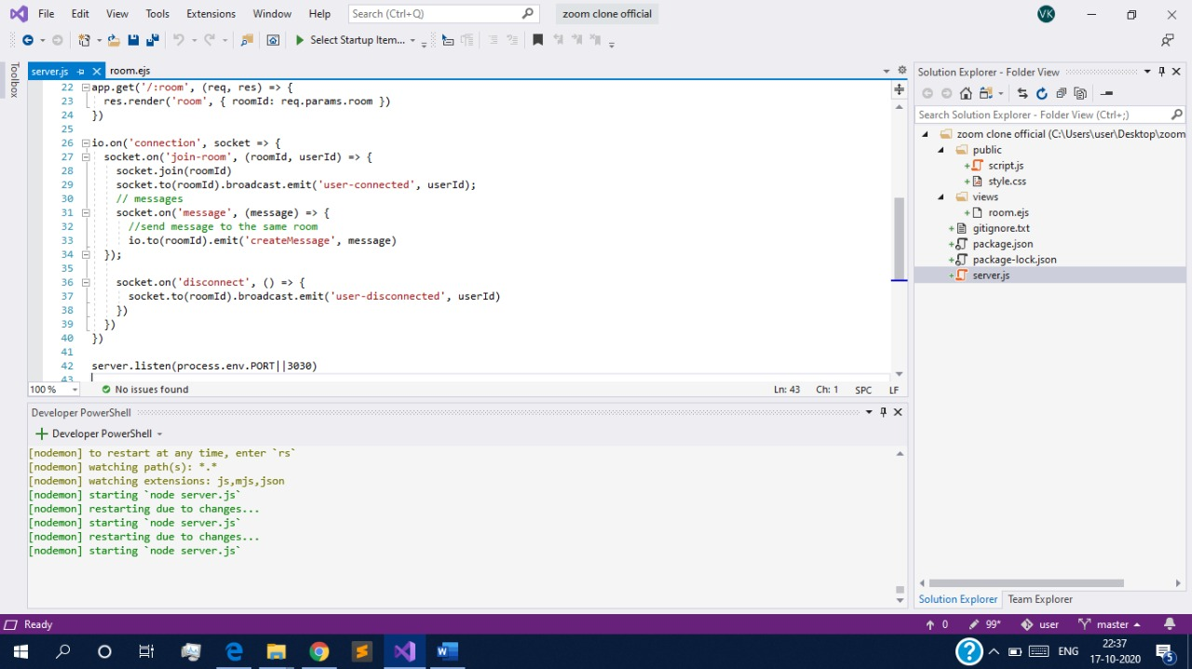

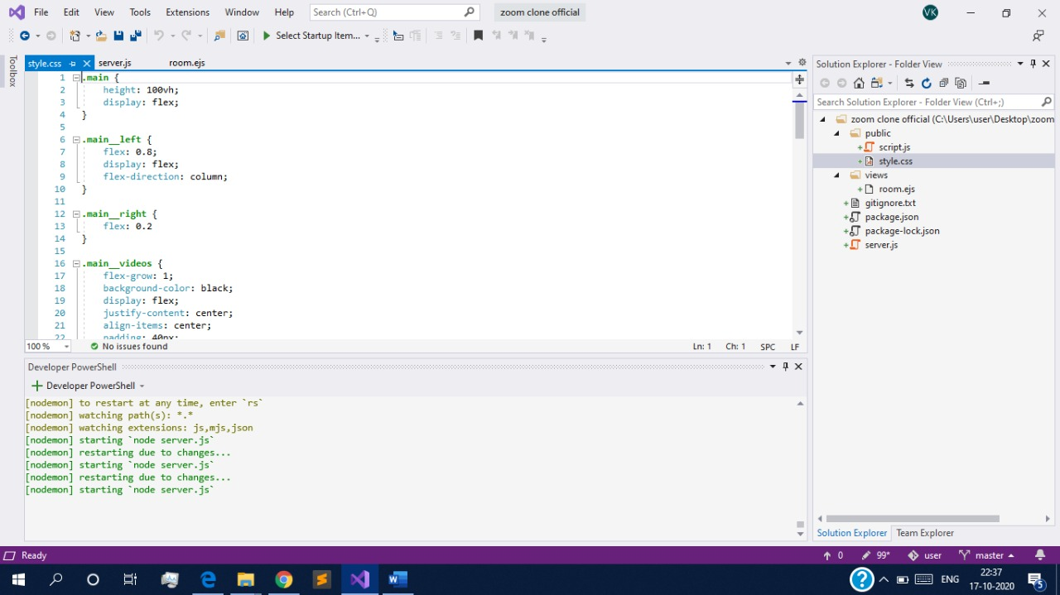

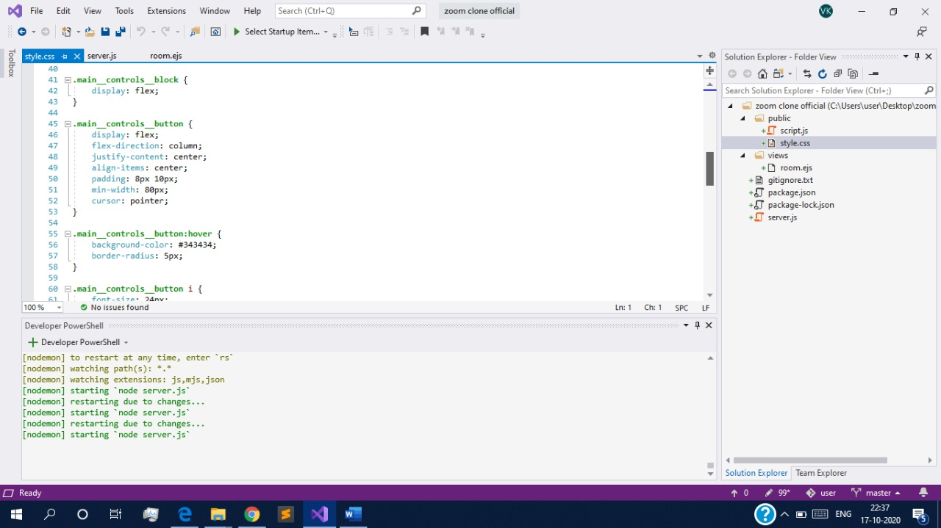

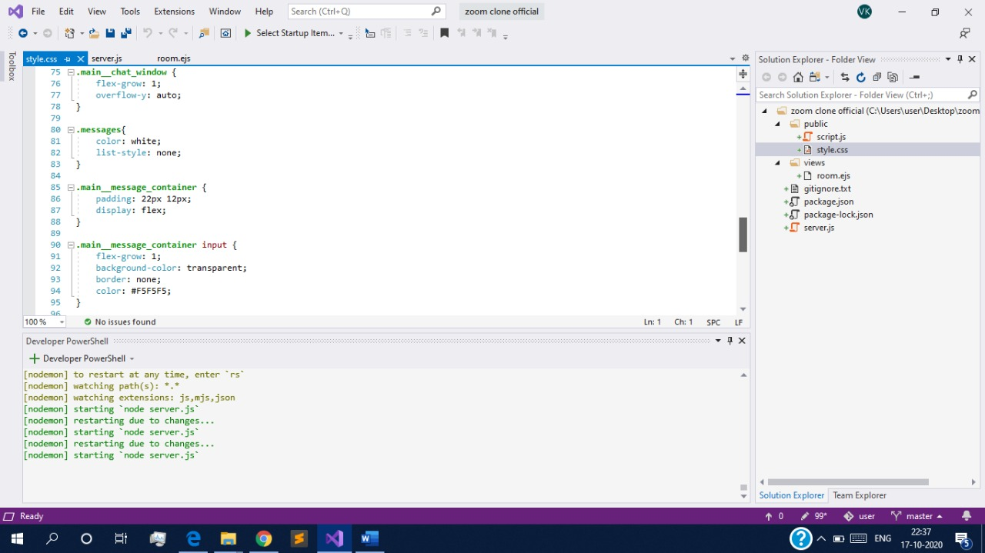

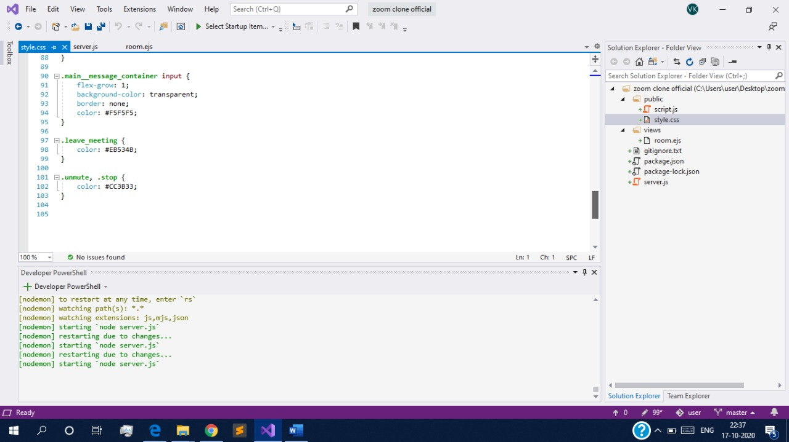

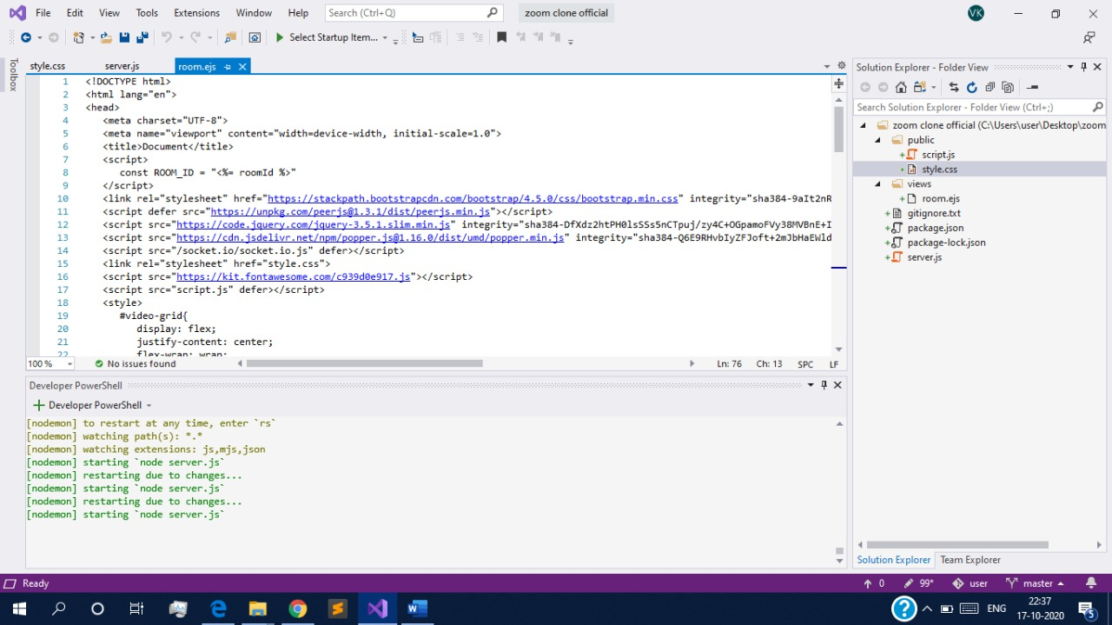

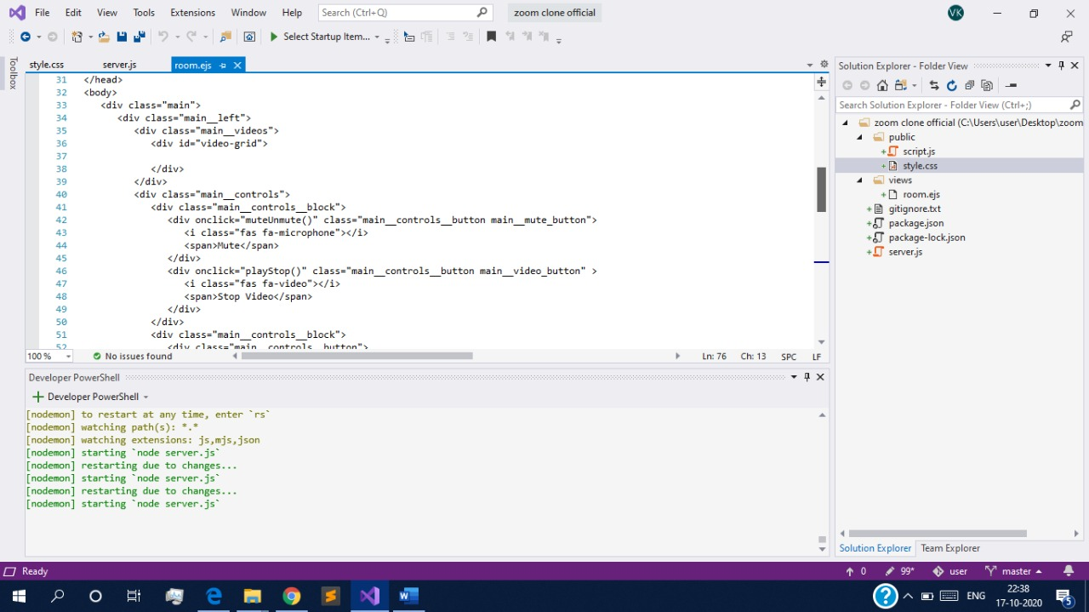

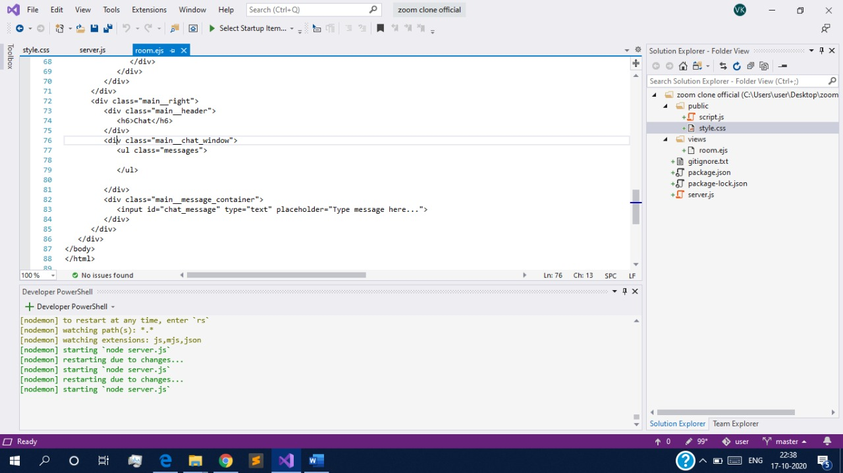

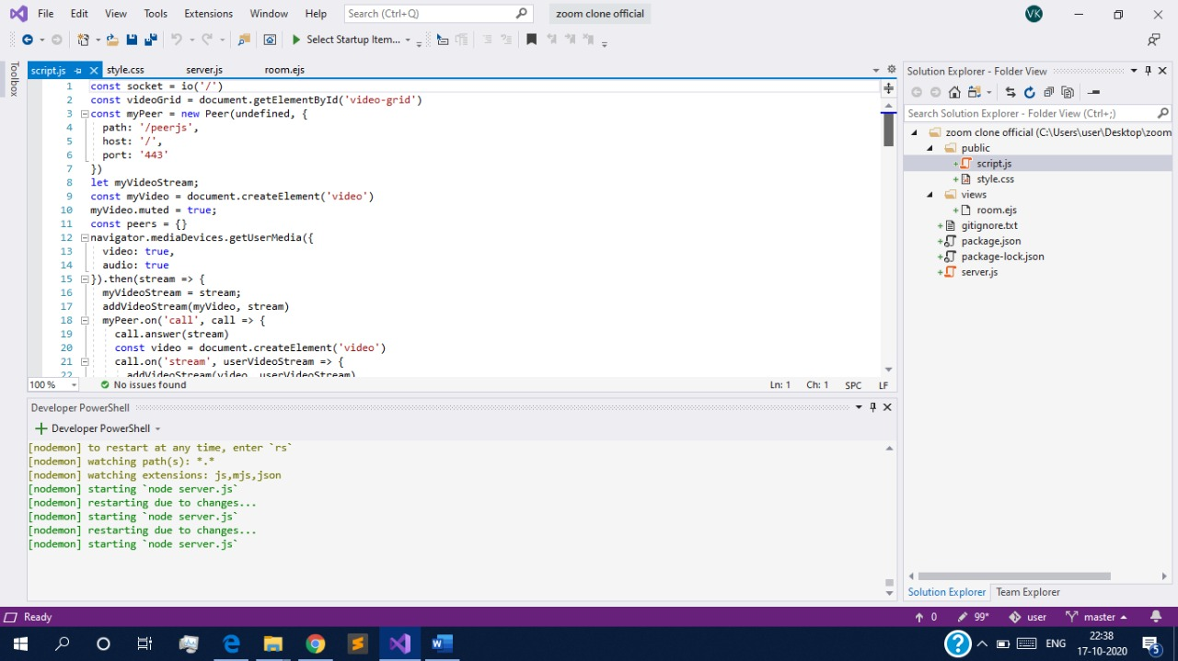

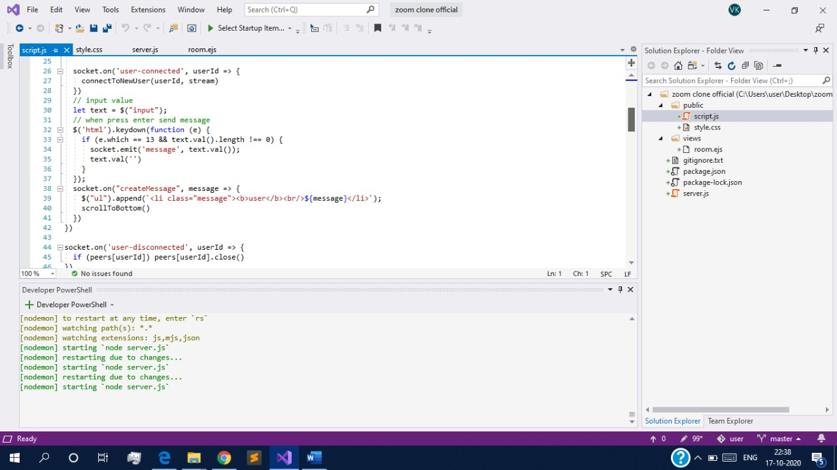

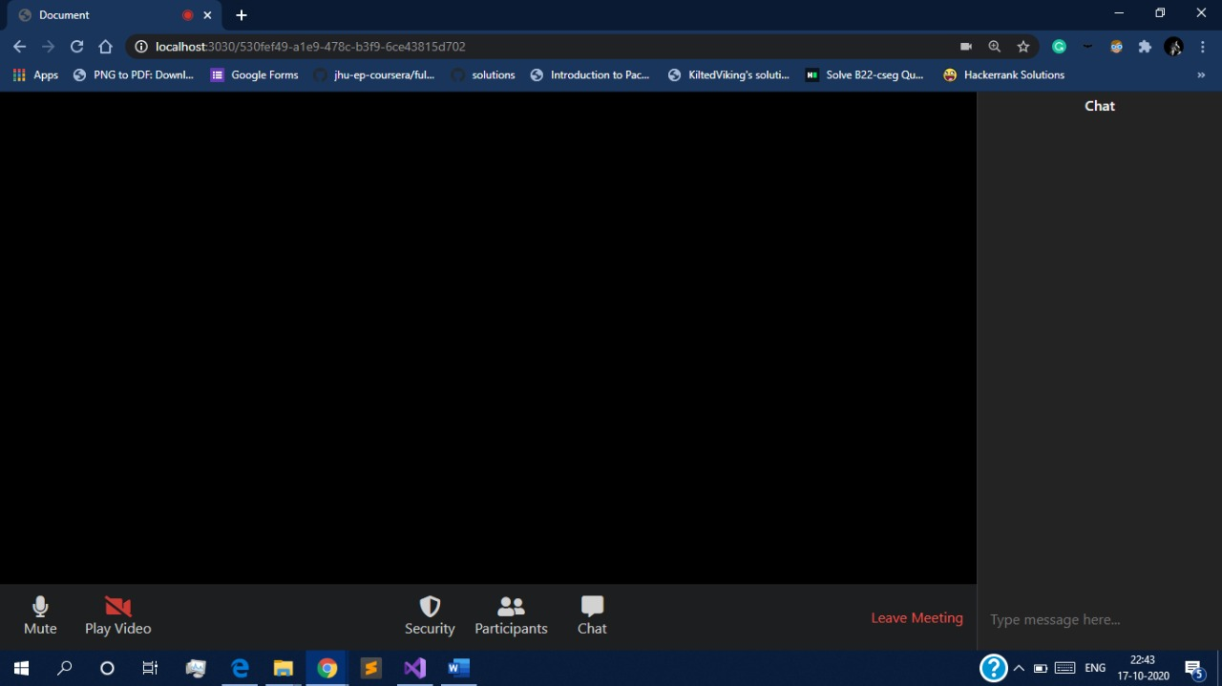

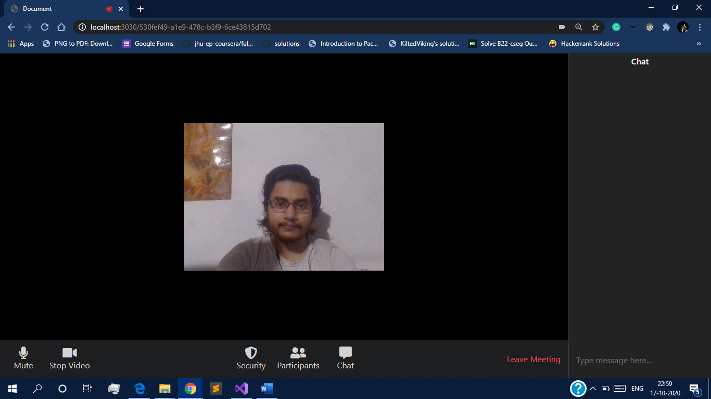

**References**

* <https://nodejs.org/en/>
* <https://socket.io/>
* <https://socket.io/>
* https://youtu.be/JnvKXcSI7yk
* https://www.geeksforgeeks.org/